

**Kawuliwa Wawa Njiye-ro Katәbe**

# **Zaman Nәngәlibe Isәna de! Faataro walle! Hangaltәne! Nәlewa'alan namne!**

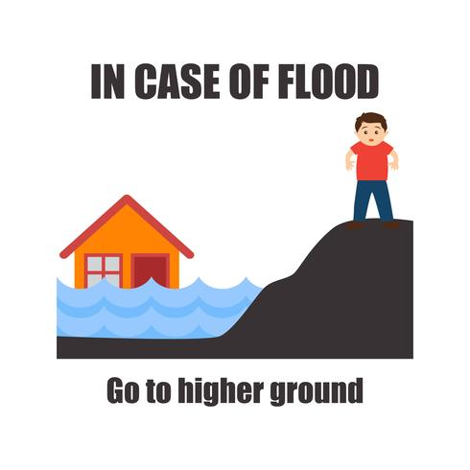

|  |  |
| --- | --- |
| IN CASE OF FLOOD Go to higher ground | WAWA NJIBE LAA WA'AJIA Na kәri hapkata kadune |

1. **Loktu nji fijinro wallonoga, nduliya fatoro dapkәgәnowo!**
2. **Wande nduliya koltә na nji-bone wawa njiben biskezanyi!**
3. **Kәlakәlan yallanәm dә isamne!**
4. **Fasal nәmngәlabe ngalwoma tawattәgәne kwasa kaltәgәro!**
5. **Wande nji njibonebe so yami. Nya kwasazәnyin diya!**
6. **Katapnәmro ciskәgәne! Njiboneso dә sa laa lan karewa dibi kam sukcin alamanna gabcuwuno gәlasbeso au shubeso gәrajin!**
7. **Wande awo kәla baa so na wawa njibe wa'azәna lan gonәmi! Waneye awo tajirwaaro waljin diya!**
8. **Kotorowo wawa niibe zamzәnaro katәne! Kumoduwula wawa nibe zuwunaso au njibone jilifi yaye lan katәne!**
9. **Sa na dә kollowo gultiya, na dә kollowo.**
10. **Fatoro waltando dә sa nandiro na dә kәlewazәna gultiya do bas!**